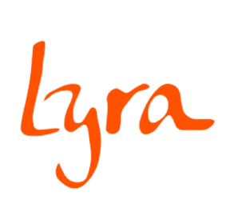

**Fact sheet: Constructing hostels to build a future for rural girls**

1. **How can we help more girls to remain in school?**

There is a clear correlation between levels of education and teenage pregnancy. As levels of education rise, the risk of pregnancy falls. 52% of adolescent girls with no education are pregnant or have given birth, compared to 10% of adolescent girls with a secondary or higher education.[1]

Completing a good quality secondary education is thus one of the most effective ways to reduce the risk of early marriage and pregnancy. Girls will have smaller, healthier and wealthier families later in life than those who do not attend school. However, in 2018 the lower secondary enrolment rate stood at only 26% in rural Tanzania (31% across Tanzania) and the upper secondary enrolment at just 6%.[2][3][4]

The central tenet of our model is to build eco-friendly, innovative low-carbon hostels for girls in ward secondary schools. These hostels provide girls with a safe spaces to live and study, giving them an opportunity to complete their studies. Hostels create a haven for girls to thrive, increasing self-confidence and well-being. In 2019, Lyra had 11 hostels which were full or over-capacity, with an average occupancy rate of 140%. Two more hostels are due to be completed in 2020.

*“After school I used to help my mother in domestic works, example in our village we have water problem so after coming back from school I had to go far (6kms) fetching water. This made me to miss some school session at evening because I had to help my mother.*

*Now I live in the new hostel at Nyangoro I have enough time to study, I’m not thinking of bad things I was facing on the way to and back to school, also I am not facing mens temptations, I got enough time to discuss with my fellow students what we have learnt at school which I had never done before. I always advise my fellow students to convince their parents to let them stay in hostel because this is a safe place for us.” Dorine Mdeke, aged 13*

Engagement with local communities is essential to the success of Lyra hostels. We encourage the community and local government to show commitment before construction starts by contributing up to 15% per cent of the cost of construction, in cash or in kind, with cash contributions from the respective District Councils.

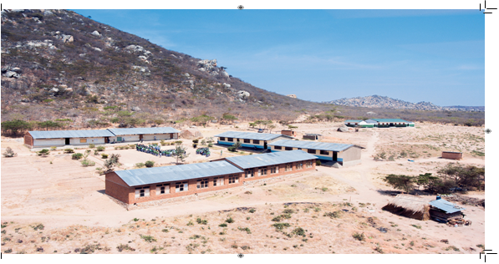

1Mazombe hostel RH corner traditional government hostel constructed by Lyra 2015

1. **Hostels create a safe space for girls to thrive**

To date Lyra has built 11 hostels with a total capacity for 850 occupants, with a 140% average occupancy rate. Lyra hostels thus provide accommodation for more than 1,000 girls every year. We have evidence that Lyra hostels are transforming lives by enabling more girls to remain at school to complete their secondary education, continuing to learn and to thrive.

**Pregnancies:** Since the beginning of the hostel construction programme in 2012, 2,400 girls have lived at our hostels with no reported pregnancies. This compares with a total of 118 girls who did not live in hostels who dropped out of seven schools between 2012 and 2019 after becoming pregnant. This is an official number, but we believe the true number to be much higher as many pregnancies are registered simply as drop-outs.

**Drop-outs from hostels**: Lyra’s evidence shows that hostels are contributing to lowering overall student drop-out rates within our schools, with just one hostel girl dropping out of secondary school to date, compared to a total of 787 students between 2014 and 2019 across seven partner schools. This is a strong indicator demonstrating just how critical hostels have been in keeping girls safe and enabling them to continue to learn and thrive.

**Academic achievement:** Lyra hostels give girls a safe space to live, but also time to study after school and at the weekends. This translates into higher academic achievements for girls living in the hostels.

Our data from five partner schools[5] shows that of the 950 girls that sat the IV exam between 2016 and 2019:

* 79 hostel girls (8.3%) were in the top performance category, compared to 23 non-hostel girls (2.4%)
* 356 hostel girls (37.5%) were in the pass category, compared to 307 non-hostel girls (32.3%)
* 76 hostel girls (8%) did not pass, compared to 109 non-hostel girls who did not pass (11.5%)

**Top performing students:** Overall, across these same schools the number of hostel girls in the top performer category is significantly higher than girls who did not live in hostels. During the four years and across all schools, there are significantly more hostel girls in the top performer category than non-hostel girls. This is a near consistent trend for the four years of data.

Graph 1.1

Top performers: Total number of hostel girls versus non-hostel girls who achieved Grade I-III between 2016-2019.

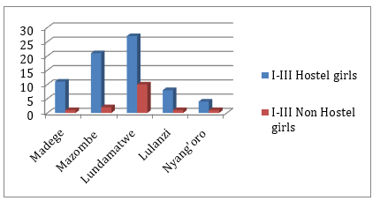

Three schools (Madege, Lundamatwe and Lulanzi) show a trend where the numbers of hostel girls in the top performing category is increasing year-on-year over the four years. This trend is not evident in the cohort of non-hostel girls.

**Failing students:** Overall, across **all 5 schools*,*** the number of hostel girls who have failed is consistently, and strikingly lower than non-hostel girls.

Graph 1.2

Failure rates: Total number of hostel girls who did not pass compared to non-hostel girls

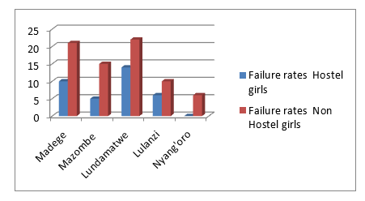

It is clear that failure rates of hostel girls have fallen over the four years across all five schools. While this trend is mirrored for non-hostel girls in four of the schools, the number of non-hostel girls who did not pass in Mazombe increased over the same period, from *3.4% in 2016 to 10.5% in 2019.*

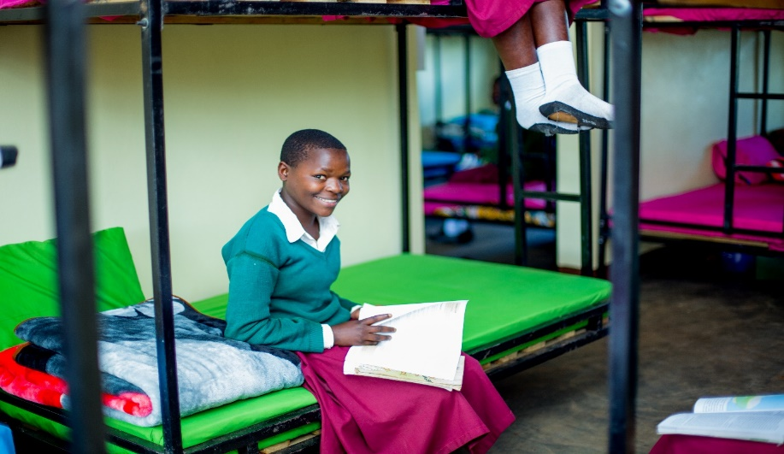

**3. How does Lyra’s hostel cost and build compare to a standard Government model?**

What makes Lyra’s innovative hostel different is primarily its low-carbon and aspirational design that takes the girls needs into consideration. Secondly, our main preferred raw material is compressed earth bricks, or Interlocking Stabilised Soil Blocks (ISSB). Soil is the major raw material for a stabilized brick and the preparation only requires labour, making this one of the cheapest ways to produce bricks. A small amount of cement (5-10%) is added to soil and manually compressed in a block press. The blocks are air-cured rather than fired. This is a low-cost, carbon-saving alternative to the traditionally used environmentally damaging fired bricks.[6]

ISSBs are more durable, with 80 % higher compressive strength on average than standard burnt bricks. Consensus across research indicates that costs per square metre are between 25% and 40% lower, due to dry stacking and less cement and mortar for plastering and rendering.[7] [8]

We promote the use of ISSB in areas where the soil is suitable, following tests by the National Housing Bureau for Research Agency (NHBRA).

We completed our first ISSB “green Lyra hostel” in 2018, and have since finished another using ISSBs. The cost per square metre works out cheaper for Lyra’s design model on a like for like basis with the standard government design, see appendix 1. We have identified areas where we can continue to deliver lower building costs by reducing the amount of cement.

Even if the conclusion were to build hostels according to the standard Government design (see appendix 2 for drawings), ISSB remains the cheapest raw material for construction, in addition to being sustainable and environmentally friendly. For a detailed breakdown of cost, see Appendix 1.

**4. What is the environmental impact of Lyra’s hostels? [9]**

There are two significant, quantifiable reductions in CO2 emissions when using ISSBs:

1. The largest CO2 reductions are from not burning bricks in the traditional way. For the production of each traditionally burnt brick an amount of 0.68 kgCO2 per brick has been used as conservative average in carbon offset projects[10]. The choice of using ISSB over burnt bricks leads to a reduction of CO2 emissions of 30tCO2 per hostel.
2. The second large reduction of CO2 emissions is the saved amount of cement used in ISSB production versus both concrete blocks and traditionally burnt bricks, representing between 11 – 13.5tCO2 emissions per hostel, using Lyra’s current cement use.

There are additional environmental costs of GHGs that we have not calculated, such as the impact of deforestation for burning traditional bricks and the amount of the very potent N2O that is released in the burning of wood. The large quantities of firewood needed for firing bricks contributes to deforestation, which also affects biodiversity. It contributes to air pollution, soil erosion and degradation, desertification of the landscape, and reduces available fuel sources for other human activities. In agricultural regions, such as where Lyra works, these consequences are especially detrimental and can contribute to food crisis.

**5. What have we learned through the development and implementation of this project?**

Our learnings have been informed by the evidence and experience of all stakeholders, including the girls who have lived in the hostels, teachers, local communities and people involved with the construction of the hostels.

**Safety and well-being for the girls:**

**In addition to the evidence presented earlier on pregnancies, drop-outs and better academic performance,** anecdotal evidence suggests that girls love having their own space and report better well-being, mental health and enjoy the interaction and learning with their peer group:

* Matrons in each Hostel take both a leadership and motherly role, which makes a big difference in the lives of the girls.
* Creating community-led, aspirational hostels with innovative design make the girls excited and adds a new pathway for better learning.
* The Ministry of Education approved hostel building (“the Government hostel design, see appendix 2) is a long corridor consisting of 20 rooms with latrines and showers. In contrast, the Lyra design provides spaces for girls to relax, study, and feel at home and very safe.
* Solar or grid power is essential for the girls to feel safe at night and be able to study after dark.

**Community and government engagement**

* Local Government (Iringa Region) endorsement and support for the Lyra model has been in place since 2018. The great milestone for Lyra was in October 2019, when the Ministry of Education endorsed Lyra’s green low-carbon design. All local governments have committed to fund at least 10% of the hostel construction cost, and to provide technical supervision by district engineers.
* The local communities have taken great pride and ownership of the Lyra hostels.
* Local masons are trained in a completely new technology for construction, saving both time and money in the long term, but more importantly saving on natural resources.
* Local communities contribute locally available material such as sand, stones, aggregates and water, representing at least 5% of the total hostel costs. In addition, the Ward Land Committee Members supervise construction daily, the schools provide storage for construction materials, and by the time a hostel is completed, a Hostel Committee led by community parents is formed with representatives from each village.
* During handover ceremonies, other Ward schools have requested Lyra to adopt the same design.

**Production and adoption of ISSB as a raw material**

* Although compressed earth blocks are an ancient method for building, they are viewed with suspicion in rural communities. Cement is seen as a requirement for “good” construction.
* There is a need for training in communities to understand the benefits of using ISSB and the decreased need for using cement and traditional bricks (a huge task to continue looking for firewood).
* Awareness of polluting emissions or environmental concerns is locally very low and not a priority.
* Close supervision is needed at the start of the project to ensure drawings are followed and that block drying and handling is correctly done.
* It is important to work with the local private sector, including local contractors and masons to promote ISSB technology.

**What we would like to develop**

* Awareness sessions to encourage local governments to adopt the ISSB technology, as a preferred way for building the much-needed schools infrastructure, where the soil is suitable.
* Training of local masons for long term environmental and local economic benefit
* A system of lending the ISSB machines and providing training to interested local community and private developers based on an agreement guaranteeing the use of the machine.
* The construction by communities of ISSB demo buildings as resource centres.
* All parties must be trained to recognise the importance of good quality raw materials and the importance of identifying the correct sand.
* Once covered by the roof, well-made blocks are weatherproof and do not require plaster.

**Appendix 1: Full Cost comparison of standard government and Lyra hostel**

Lyra ‘s hostel costs approx. USD86,000 or USD140/sqm versus the government used standard hostel design at USD81,000 or USD180/sqm. In addition, the environmental costs are drastically reduced by using compressed earth bricks that are air cured as the main raw material, reducing CO2 emissions by approx. 58t per hostel when compared with a hostel built using traditionally burnt bricks.



* Burning wood releases about 1,900g of CO2 for every 1,000g of wood that is fully burnt. We have only calculated the CO2, not other GHGs, such as N2O.

Assumption that wood can be considered as non-renewable biomass, a range of 0.19 -1.75kg CO2 emissions per clay fired brick. The GET uses 1.08kgCO2 / brick.

**Appendix 2: Drawings for Lyra and Government Hostels:**

Lyra’s hostel creates a secure inner courtyard planted with fruit trees surrounded with social space for the girls to relax, study and spend time with their peer group. It includes toilets and laundry area. It sleeps 96 girls in 12 bedrooms in a space of 596 sqm. A matron’s studio is included within the design.



The Government standard hostel is set out as a long corridor with space for 20 bedrooms with an added block for laundry and toilets. It sleeps 80 girls in 450 sqm.



1. TDHS 2015/16
2. <https://tradingeconomics.com/tanzania/gross-enrolment-ratio-upper-secondary-female-percent-wb-data.html>
3. https://tradingeconomics.com/tanzania/gross-enrolment-ratio-primary-and-secondary-both-sexes-percent-wb-data.html
4. School enrolment, secondary, female (% gross) in Tanzania was reported at 30.13 % in 2018, according to the World Bank collection of development indicators, compiled from officially recognized sources. Tanzania - School enrolment, secondary, female (% gross) - actual values, historical data, forecasts and projections were sourced from the World Bank on May 2020 and Appendix 1
5. Lyra’s five partner schools: Madege, Mazombe, Lulanzi, Nyangoro, Lundamatwe
6. United Nations Human Settlements Programme (UN-HABITAT): Interlocking Stabilised Soil Blocks -Appropriate earth technologies in Uganda: “Appropriate technology that doesn’t cost the earth”
7. United Nations Human Settlements Programme (UN-HABITAT): Interlocking Stabilised Soil Blocks -Appropriate earth technologies in Uganda: “Appropriate technology that doesn’t cost the earth”
8. Simeon Kintingu: Doctorate Thesis: DESIGN OF INTERLOCKING BRICKS FOR ENHANCED WALL CONSTRUCTION FLEXIBILITY, ALIGNMENT ACCURACY AND LOAD BEARING, University of Warwick, May 2009
9. See appendix 1 for full calculations on costs and externalities
10. Roadmap to registration: Feasibility of Developing a COM Methodology and its

    implications on a Project using Interlocking Stabilised Earth Blocks as a Greenhouse Gas reducing building technology, Study for the Good Earth Trust, www.do-inc.net, March 2010